**Application Load Balancer**

An **Application Load Balancer (ALB)** in AWS is a fully managed service that automatically distributes incoming HTTP and HTTPS traffic across multiple targets—such as Amazon EC2 instances, containers (ECS), IP addresses, and Lambda functions—within one or more Availability Zones.

Or

The **Application Load Balancer (ALB)** is a **Layer 7 (HTTP/HTTPS)** load balancer in AWS that distributes incoming traffic across multiple targets (e.g., EC2 instances, containers, Lambda functions) based on advanced routing rules. It’s designed for modern applications with micro services architectures.

**Feature of Application Load Balancer:**

* It isoperated at the 7th layer (application) of the OSI model.
* Routes traffic based on **HTTP/HTTPS headers** (URL), paths (/api, /app), hostnames (app.example.com), or query parameters.

1. Path-based routing (/admin → Admin servers).
2. Host-based routing (blog.example.com → Blog servers).
3. Redirects (HTTP → HTTPS).

**Example:** Send /images requests to one server group and /api to another.

* It supports regional level only.
* It supports WAF (web application firewall) to protect against web attacks.

Now let’s work practically with the Application load balancer:

Create an Application load balancer and add two EC2 instance (in which Nginx is installed on them) at the target group of load balancer and brows the Nginx web page using the DNS name of the application load balancer.

**Step1:** Create the two EC2 instance (instance-01 & instance-02).

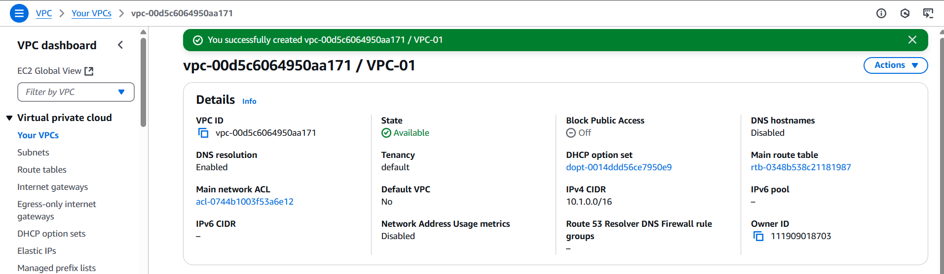

Fig: Virtual private cloud (VPC-01).

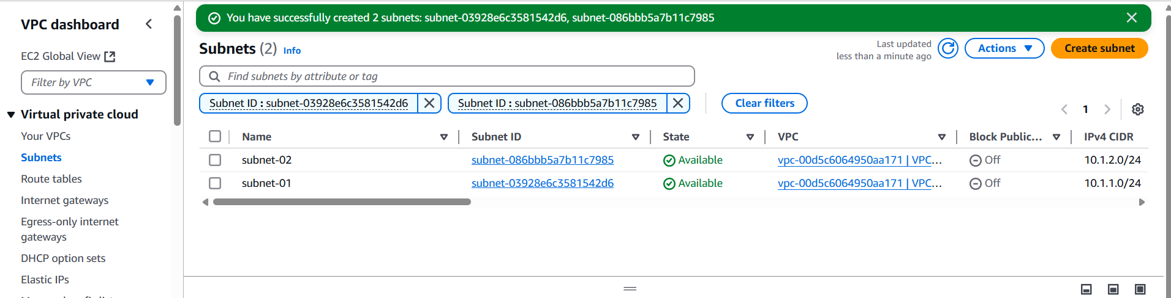

Fig: Two subnets (subnet-01 & subnet-02).

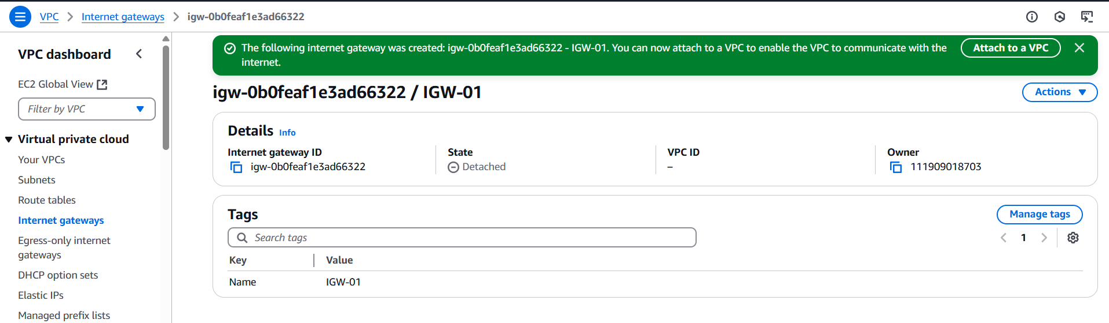

Fig: Internet gateway (IGW-01). Attach it to the VPC-01

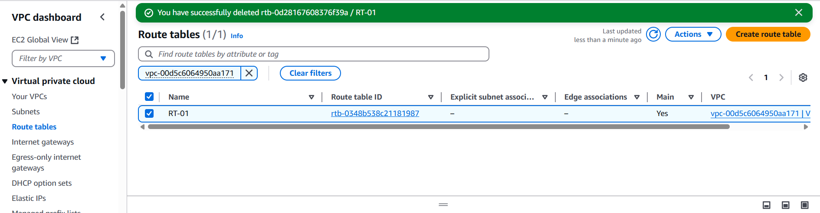

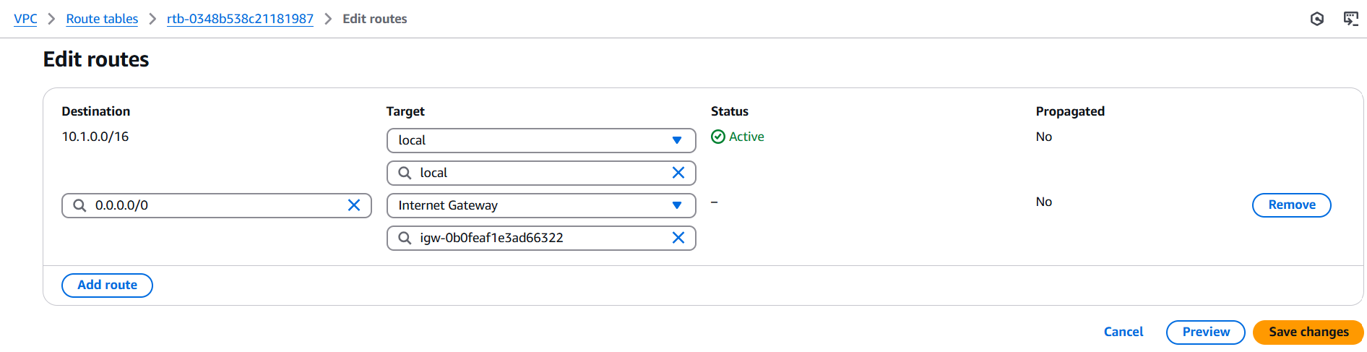

Fig: Configuring Route table.

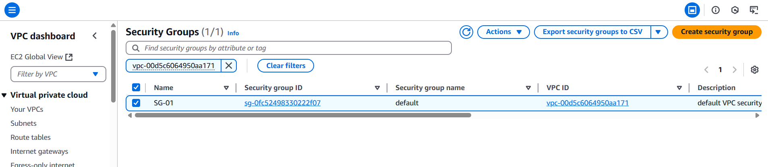

Fig: Security group (SG-01).

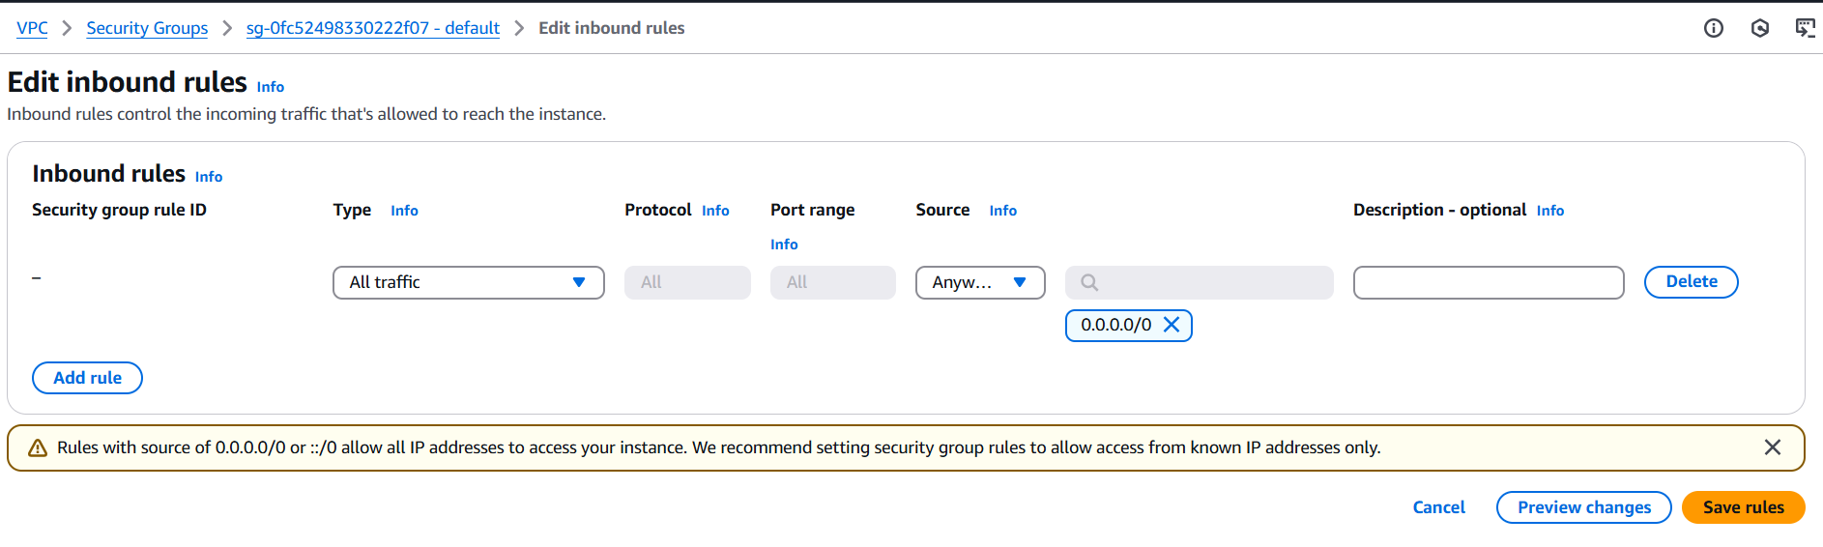

Fig: SG inbound rules.

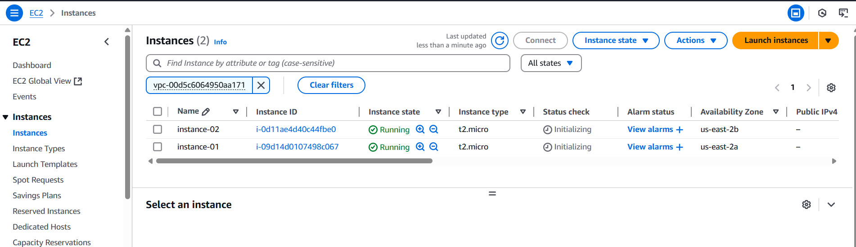

Fig: Two EC2 instances (Instance-01 & instance-02) are created successfully.

**Step2:** Now install the web server Nginx in both the instances (Instnace-01& Instances-02).

Installing of Nginx server:

1. sudo su
2. apt update
3. apt install nginx -y

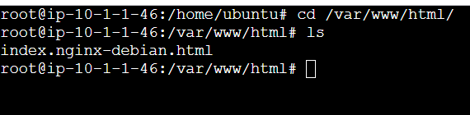

Fig: Nginx web server in instance-01.

**Note:** Now in instance-02 install the Nginx, edit the content in it as shown below figure (Welcome to Vcube software solutions!) and create folder (solutions) and move the Nginx file (index.nginx-debian.html) to that folder.

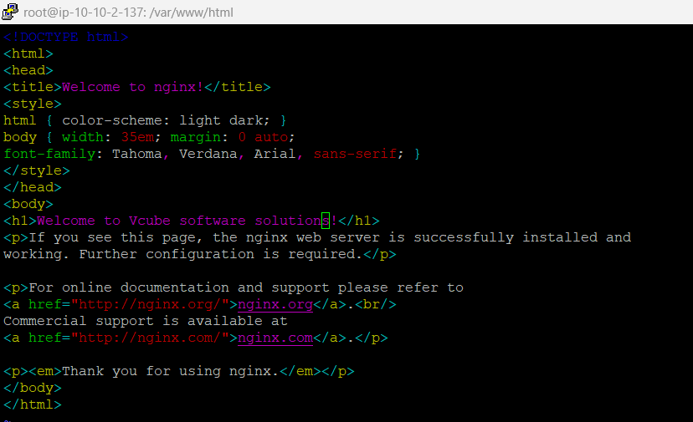

Fig: Editing of Nginx web page content of instance-02.

In order to route the traffic based on “Path”, we have to place our Nginx web server file (index.nginx-debian.html) in a separate folder as shown below figure.

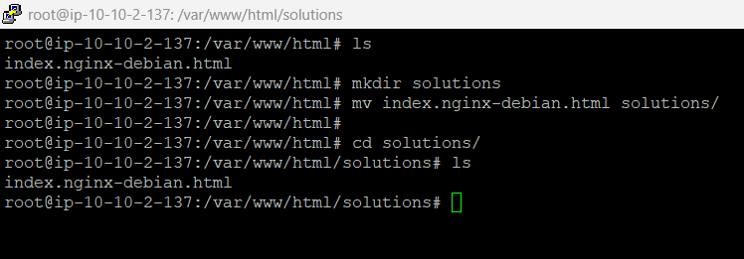

Fig: Moving Nginx file to the separate folder (solutions).

So that we can easily brows using path based as shown in below figure.

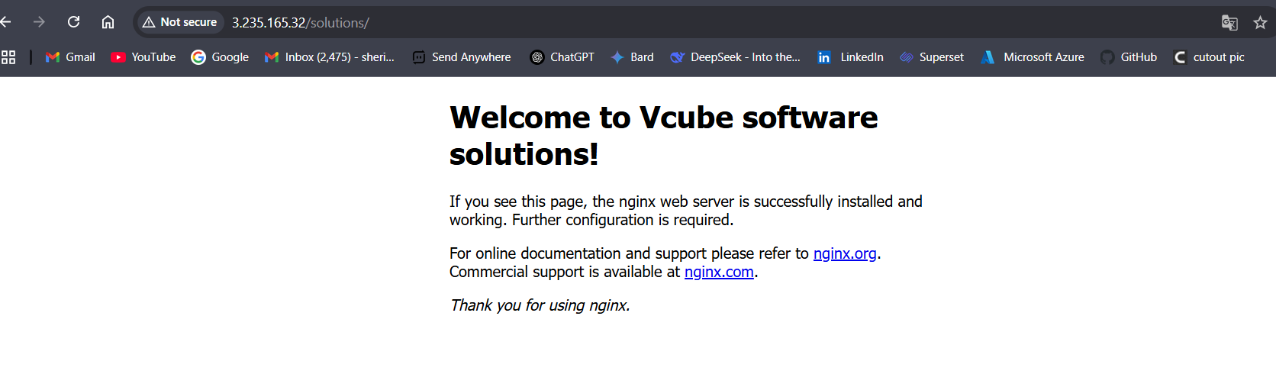

Fig: Path based routing. (<http://3.235.165.32/solutions/>).

**Public IP’s:**

Instance-01 🡪52.205.31.98

Instance-02 🡪 3.235.165.32

**Step3:** Create an Application Load Balancer and add these two instance (Instnace-01 & Instance-02) in its target group.

**Note:** Here we have to create two target groups, one is for “**home page”** and other is for “**solutions page**”.

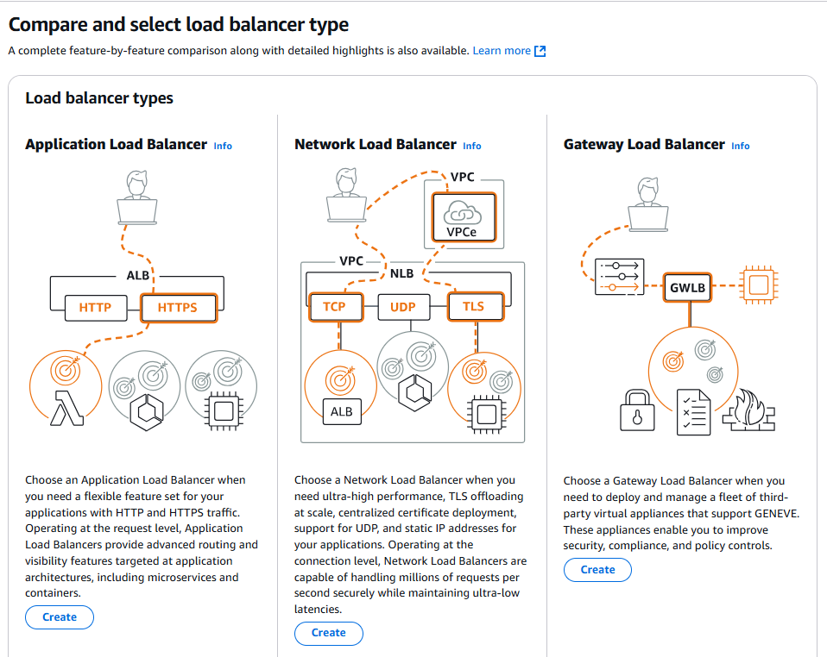

Fig: Application Load Balancer.

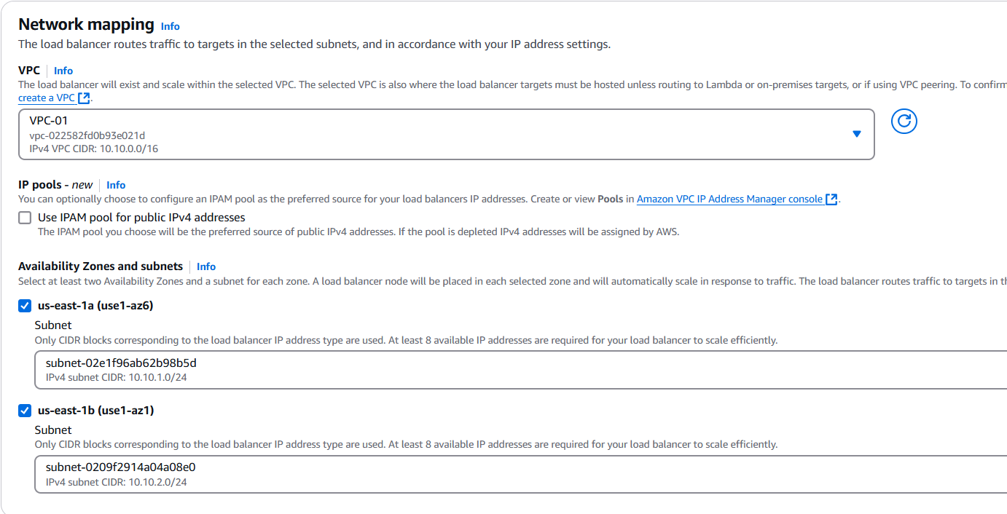

Fig: Select both subnets.

Now we have to create two target groups one IS home page and other for solutions page (Home-TG & Solutions-TG).

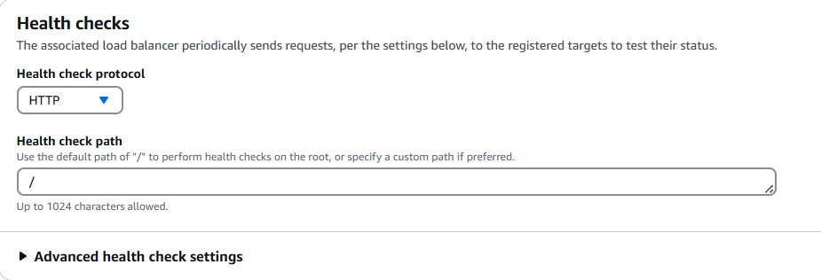

**Fig:** Health check path for Home-TG.

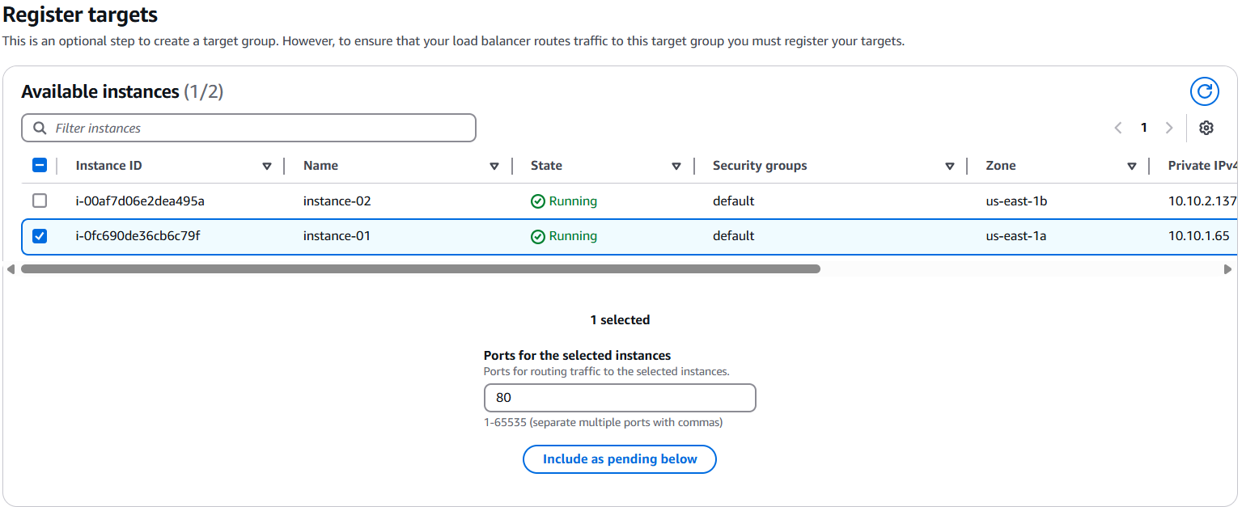

Fig: Adding the instance-01 to a target group Home-TG.

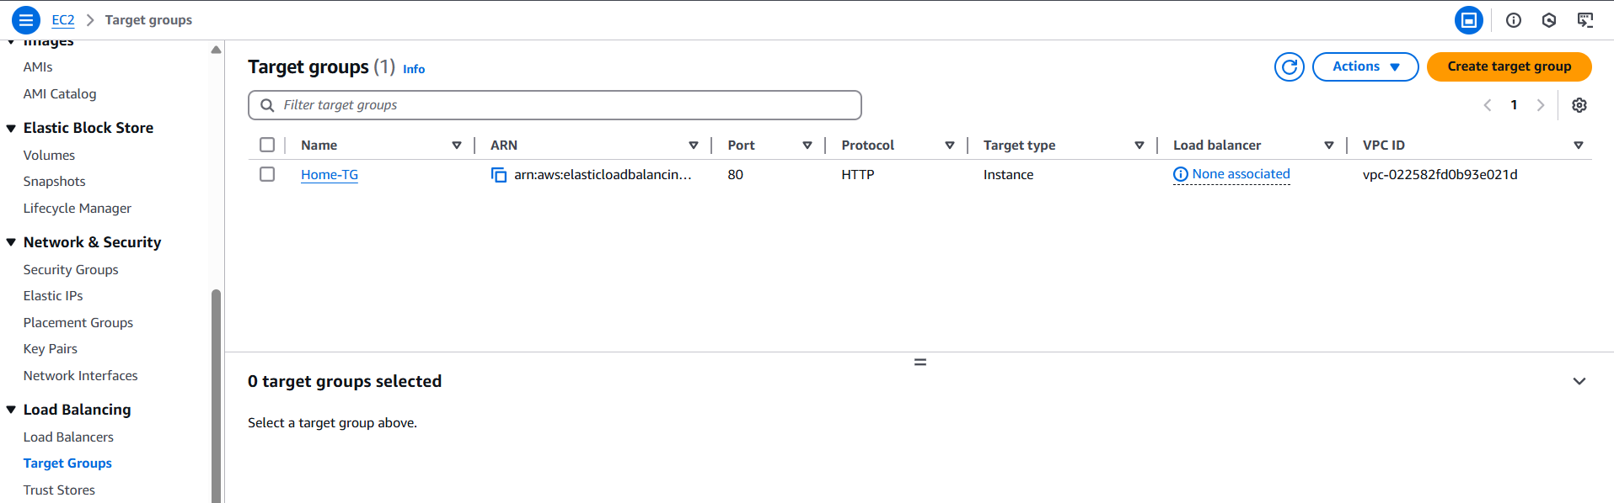

Fig: Home target group (Home-TG) is created successfully.

Now create another target group for the solution page (solutions-TG).

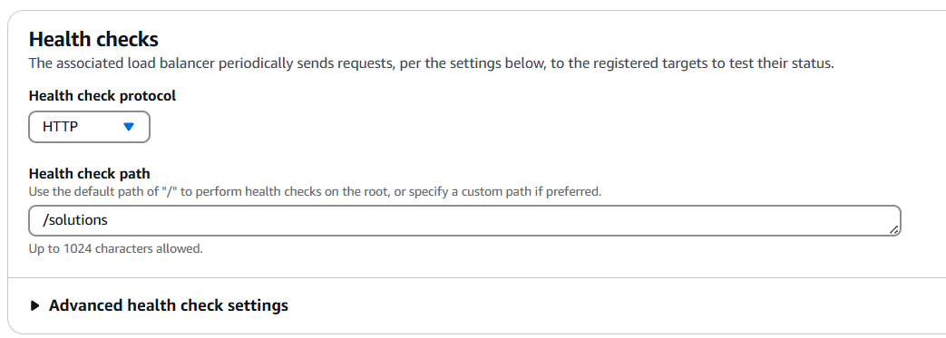

Fig: Health check path of solutions-TG.

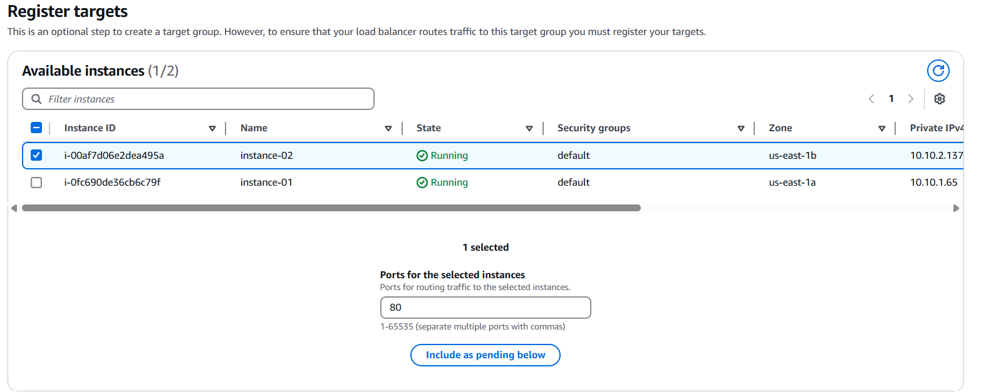

Fig: Adding of instance-02 to the solutions-TG.

Now go back to the Load Balancer configuration settings and add Home-TG as a default target group for the Application load balancer.

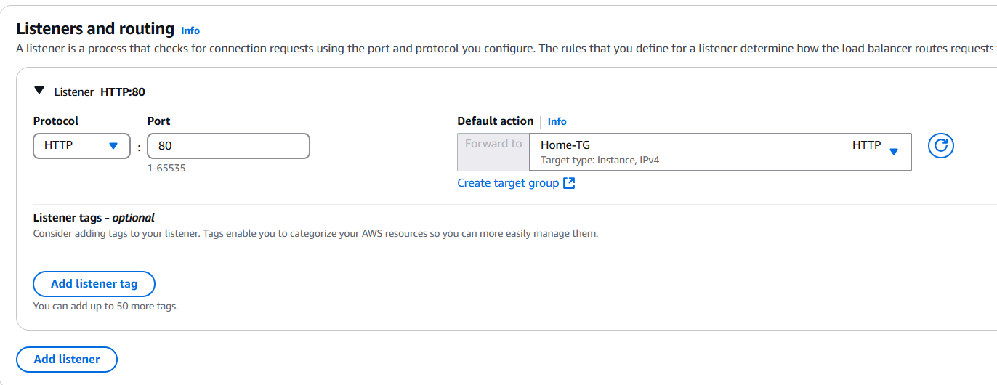

Fig: Using the Home-TG as a default action.

That above figure says that if someone (user) brows using the DNS name of Application load balancer, by default the traffic routs to the home page of Nginx web page, if they browse using DNS name with path (/solutions) it will hit instance-02 server (welcome to Vcube software solutions).

To work the above concept correctly we have to do some configurations in the load balancer target group as shown below:

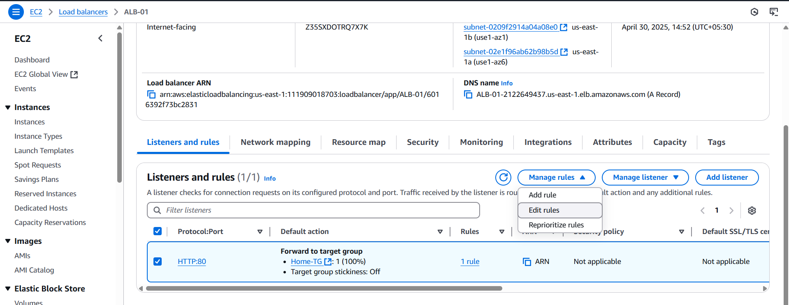

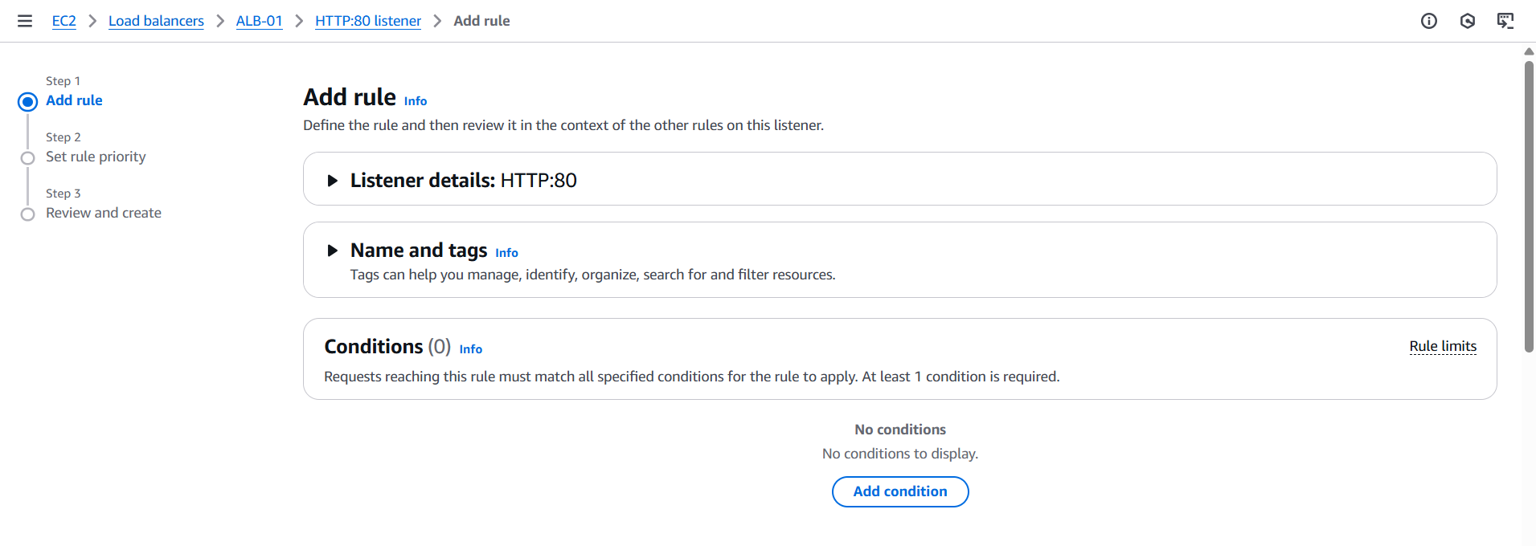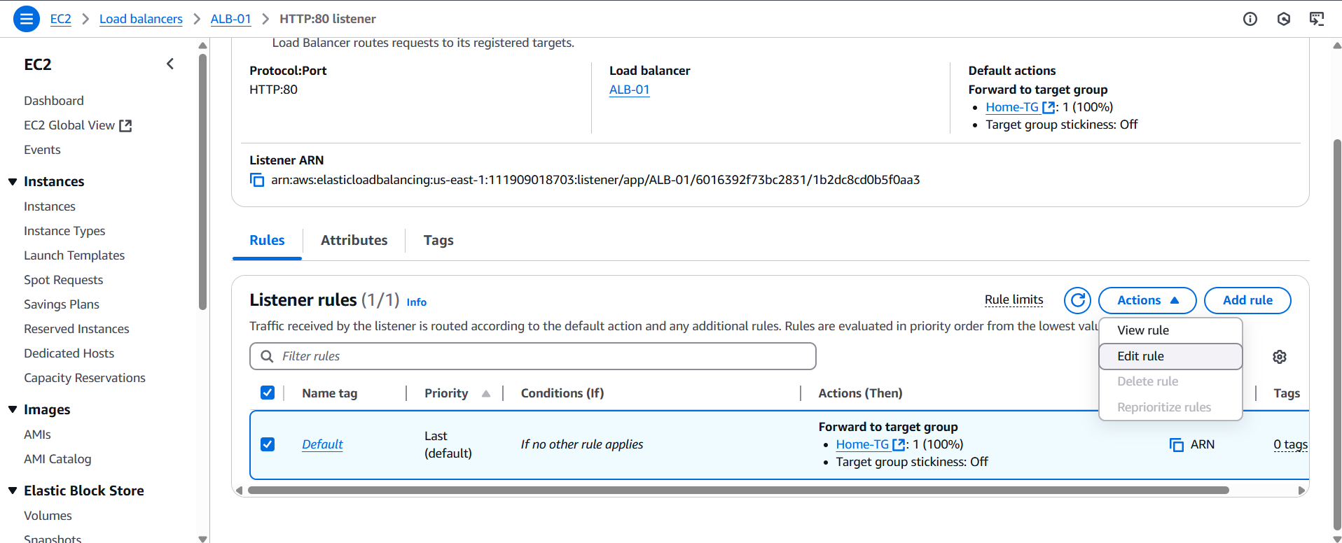

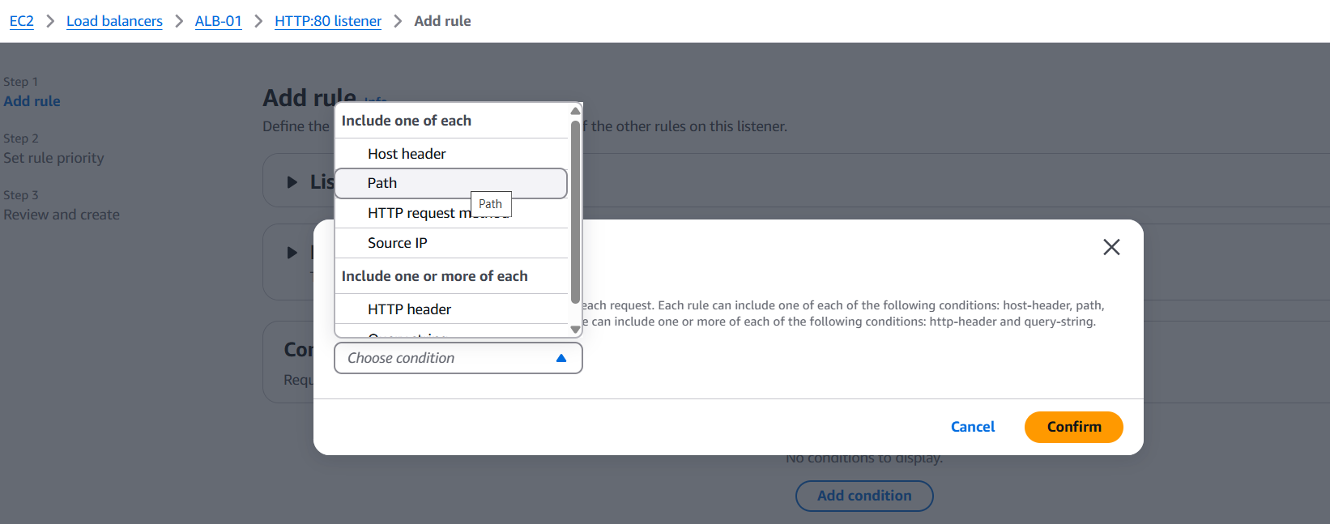

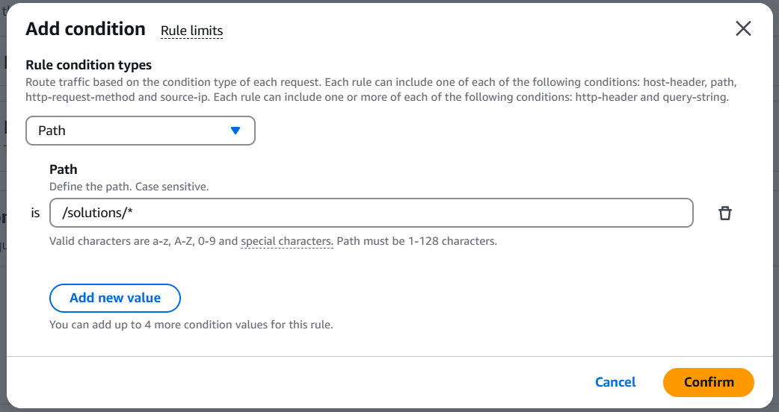

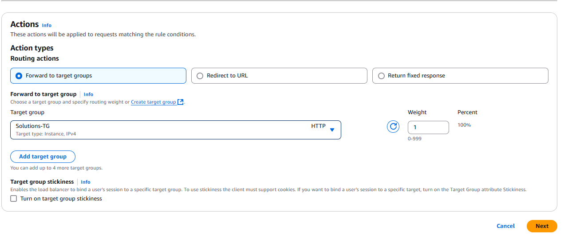

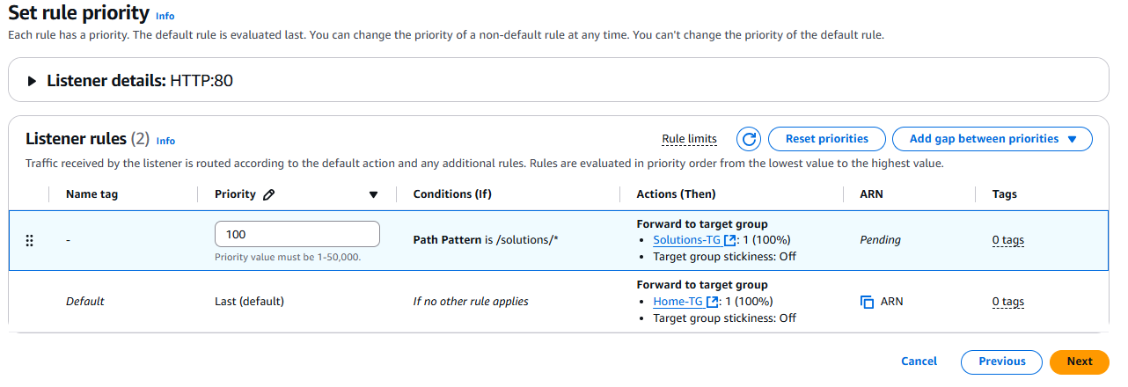

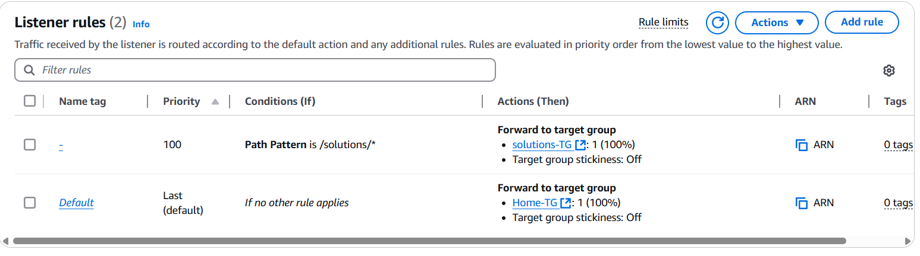

Fig: Two target groups are added with some conditions (path).

Now browse in any browser as follow:

Application Load Balancer DNS name: ALB-01-2122649437.us-east-1.elb.amazonaws.com

Default traffic hit: ALB-01-2122649437.us-east-1.elb.amazonaws.com (Instance-01)

Path based traffic hit: ALB-01-2122649437.us-east-1.elb.amazonaws.com/solutions/ (Instnace-02).

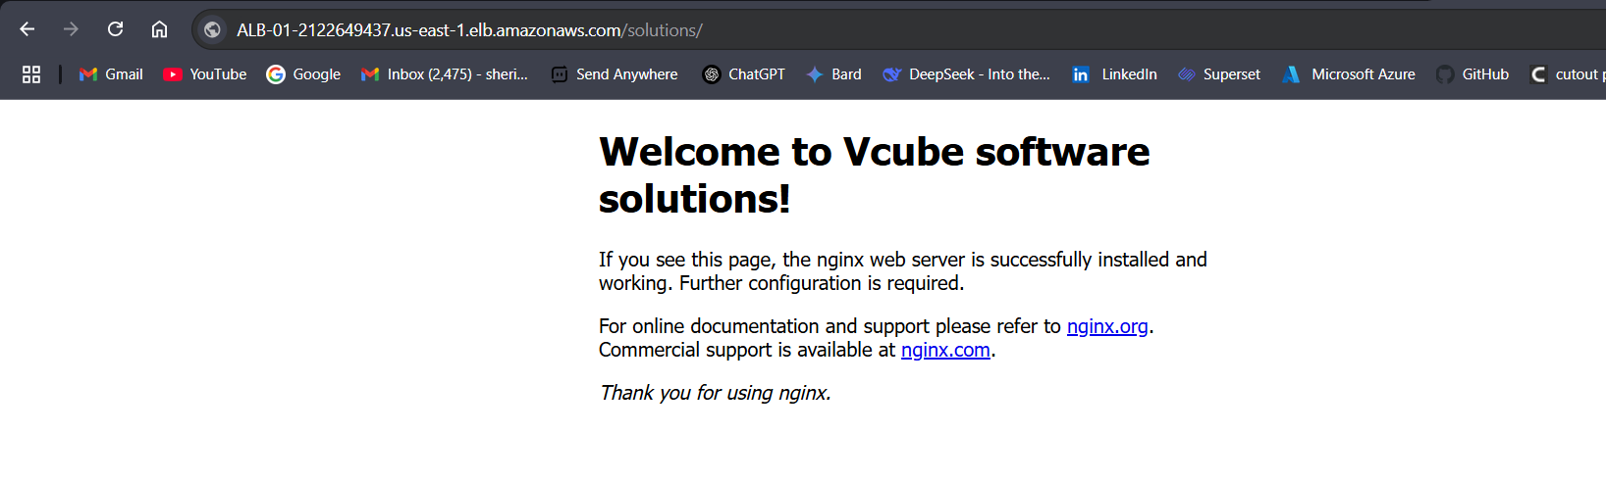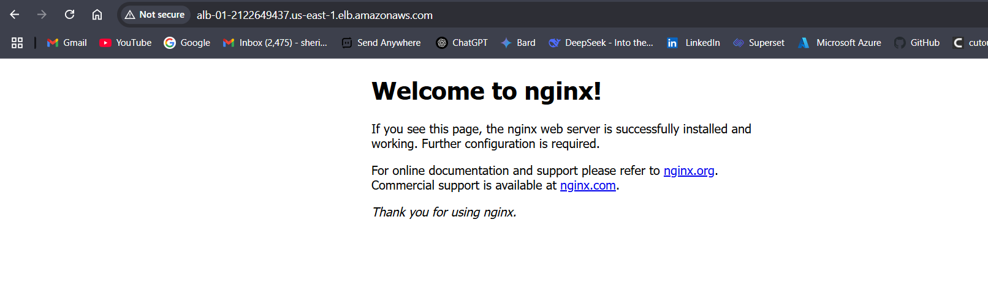

**Block Diagram:**

The block diagram of above performed task.

DNS name: ALB-01-2122649437.us-east-1.elb.amazonaws.com

Internet

ALB

/solutions/

**/**

VPC-01

Subnet-02

Subnet-01

User

Instnace-01

Instnace-02

**WAF (Web application Firewall):**

* AWS WAF is a security tool that helps protect your website or web app from **bad traffic and attacks**.
* It's a security layer that helps you control which HTTP(S) requests are allowed or blocked before they reach your application.
* Protect against Common Attacks SQL Injection, Cross-Site Scripting (XSS), Command injection, OWASP Top 10 threats and Global blocking can also performed.

Now let’s configure the WAF (web application firewall) to the Application Load Balancer (ALB).

To implement the WAF first we have to configure/create an IP set, and this IP set is added the WAF.

Case01: Create IP set.

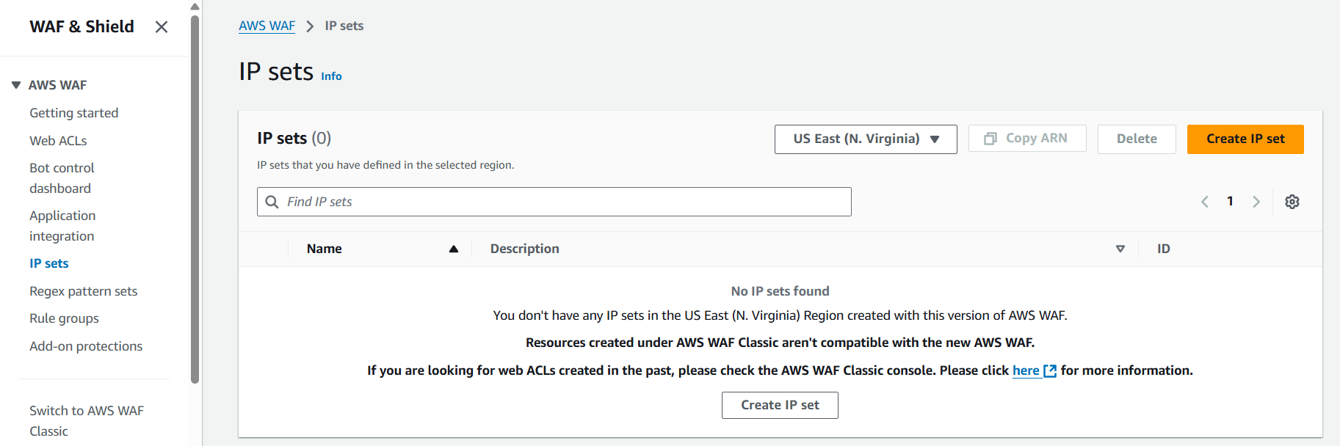

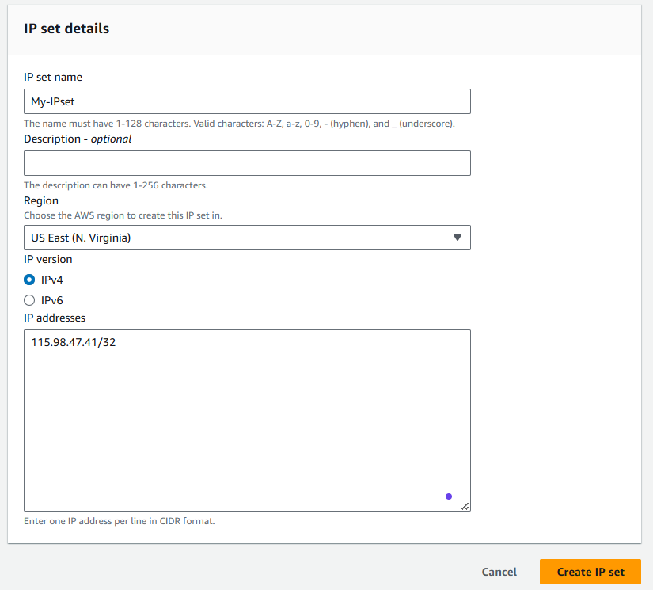

My local machine Public IP.

Fig: IP set configuration.

**Note:** While giving single IP rage the CIDR range should be 32.

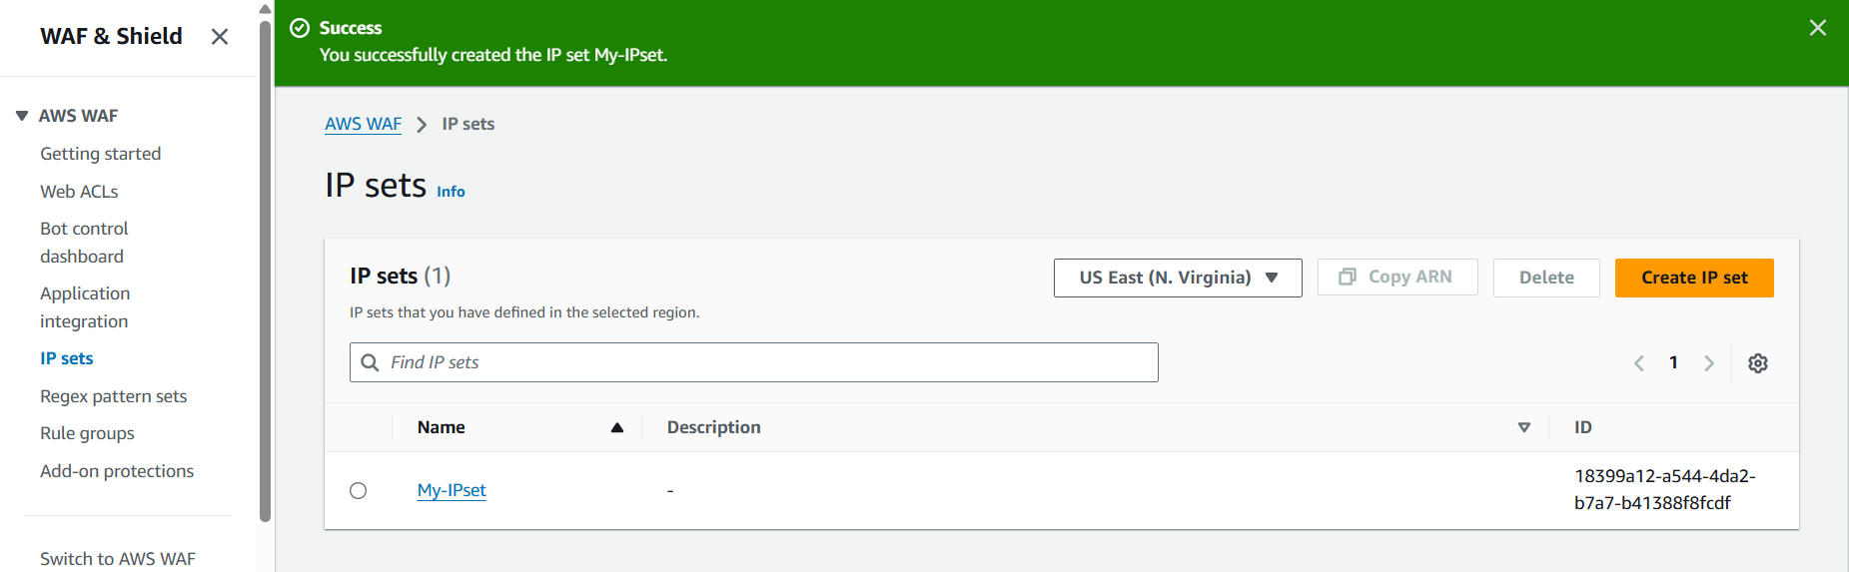

Fig: IP set (My-IPset) is created successfully.

Case02: Create the WAF ACL by adding the IP set (My-IPset) to it.

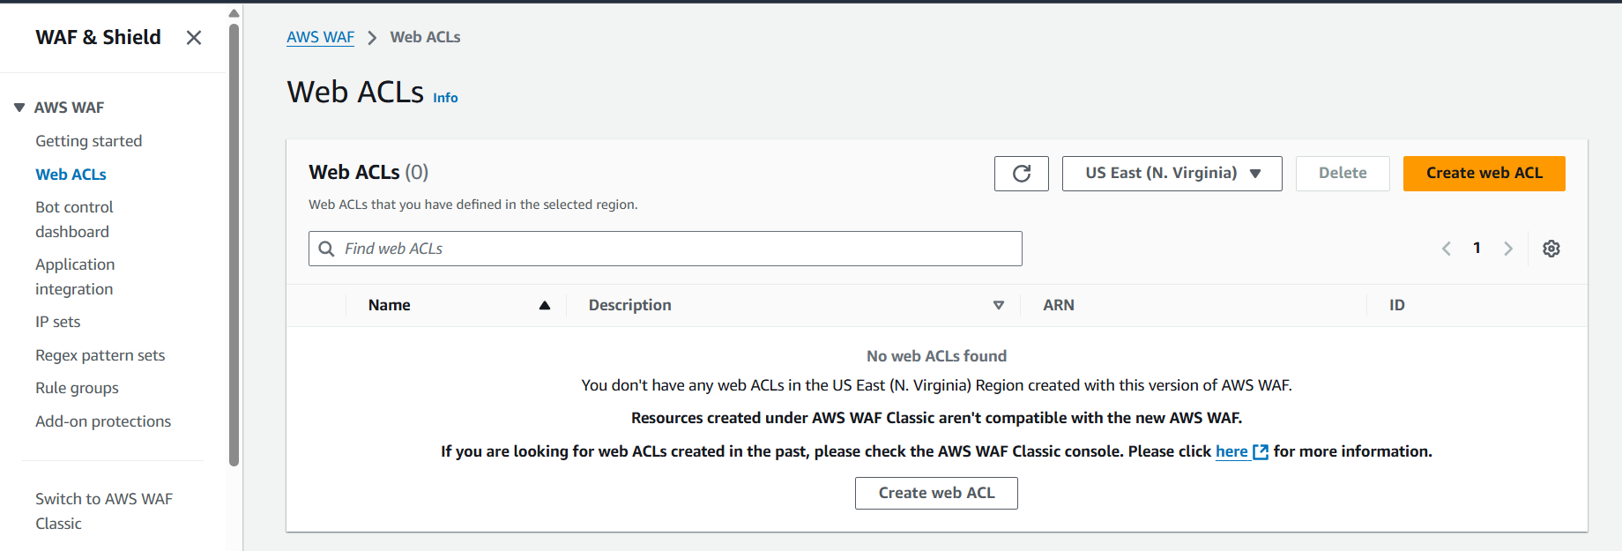

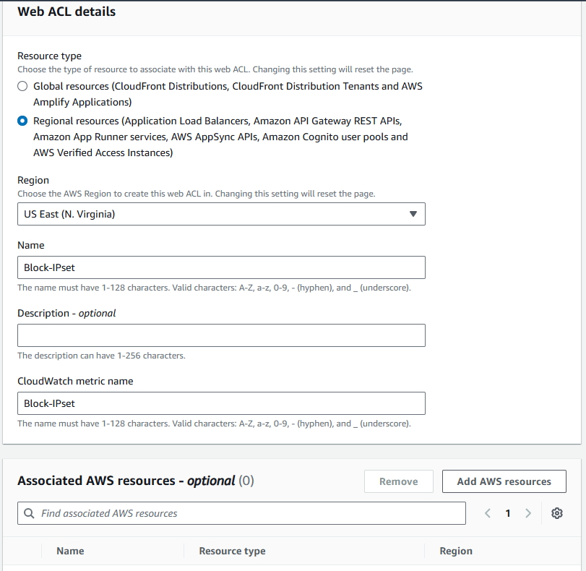

Fig: Add AWS resource.

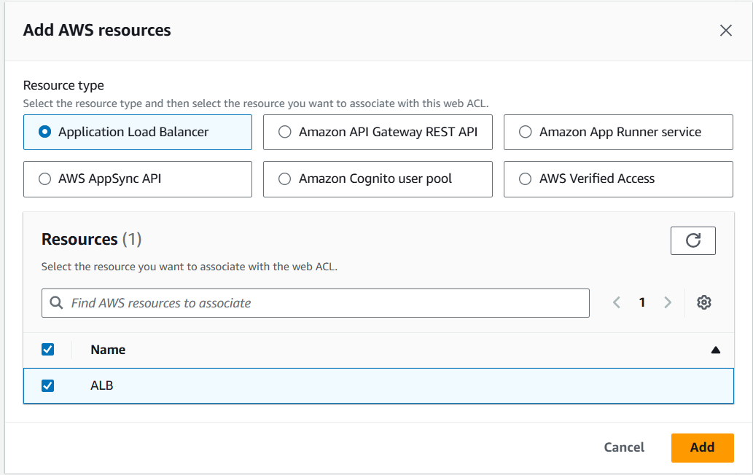

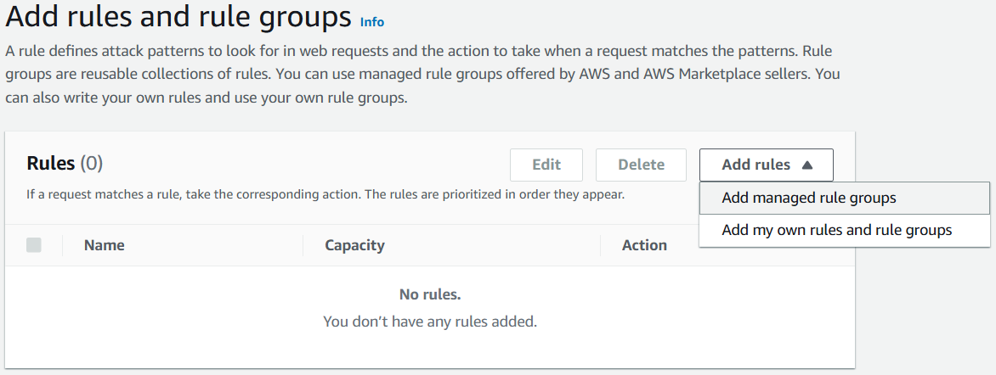

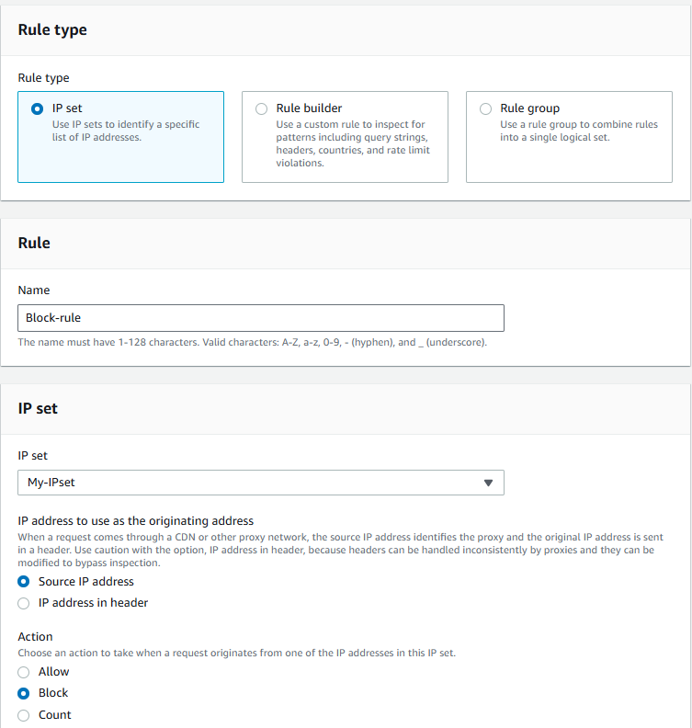

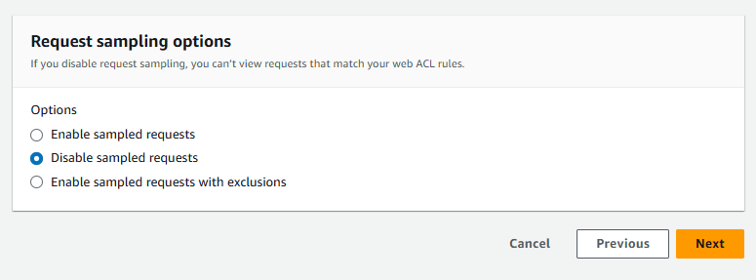

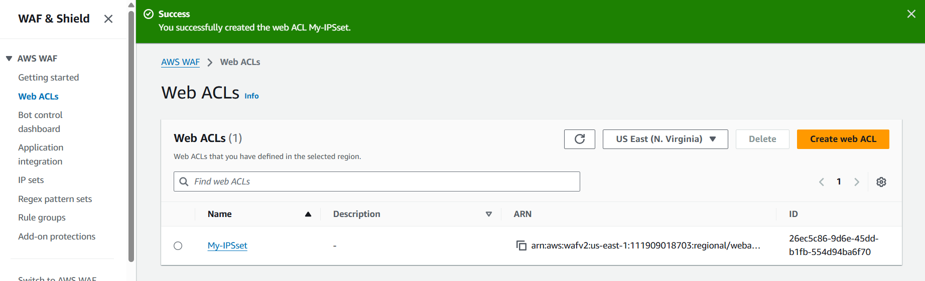

Fig: WAF ACLs created successfully.

Here we wrote our own WAF rule that whatever the Public IP’s present in the IP set should block, while accessing the Application load balancer target group instances.

**WAF ALCs:** web application firewall Access control list.

**Case03:** Let’s check whether we are able to access the target group instances using DNS name of Application load balancer.

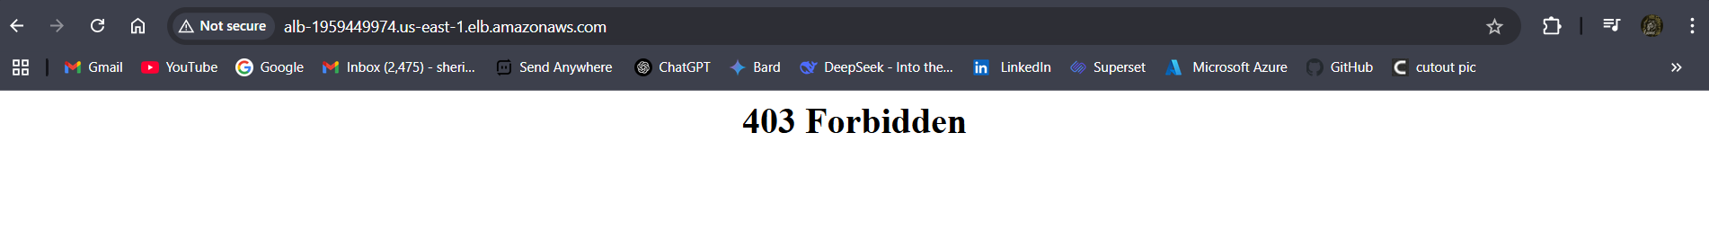

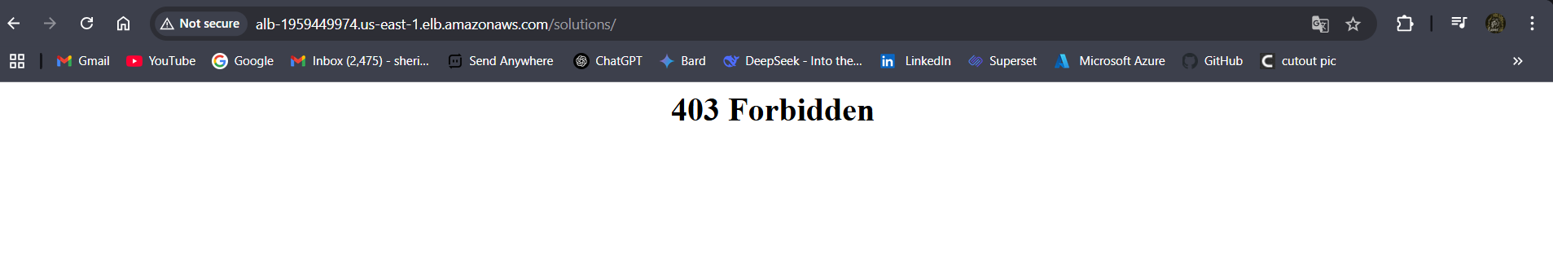

Now we are unable to access the webserver.

**Blue Green Deployment strategy**

**Blue-Green Deployment** is a deployment strategy that helps **reduce downtime** and **risk** when releasing new versions of an application.

The blue green strategy is mainly used to switch between the older versions to the new version of our application with zero downtime. And also we can easily roll back to previous version if in case any issues arise with new version.

**How it works:**

* You have **two environments**:
  + **Blue** = the **current** (live) version of the app
  + **Green** = the **new** version you want to release

**Deployment Steps:**

1. **Deploy the new version** of your app to the **Green** environment.
2. **Test** the Green environment to make sure everything works.
3. **Switch traffic** from Blue to Green (usually done with a load balancer or DNS).
4. If something goes wrong, you can **quickly switch back** to Blue.

**Benefits:**

* **Zero downtime** deployment
* **Easy rollback** if the new version fails
* Safe way to test in **production-like conditions**

**Real-World Example:**

Your website is live (Blue). You build a new version (Green), test it, and then flip a switch to send all users to Green. If it breaks, you flip the switch back to Blue.

**Note:** Blue-Green deployment is **not limited to ALB**. It's a **flexible strategy** that can be used with **ALB, Route 53, Beanstalk, ECS, Lambda, and more** depending on your architecture.

Let’s work with blue green deployment strategy using Application Load Balancer (ALB).

Step1: Create EC2 instance (Prabhas-server).

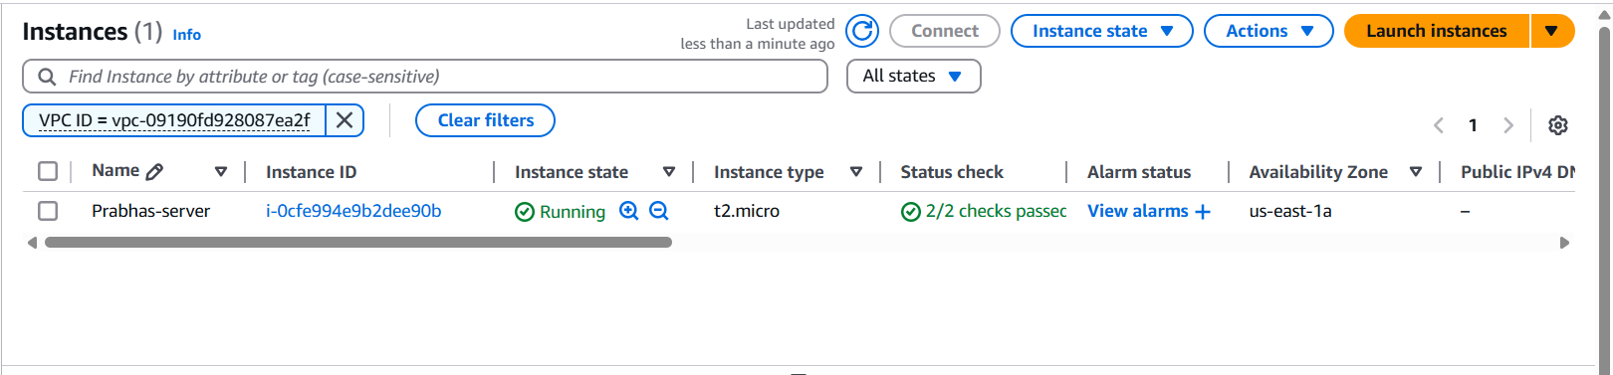

Fig: Prabhas-server instance.

Step2: Create an application load balancer.

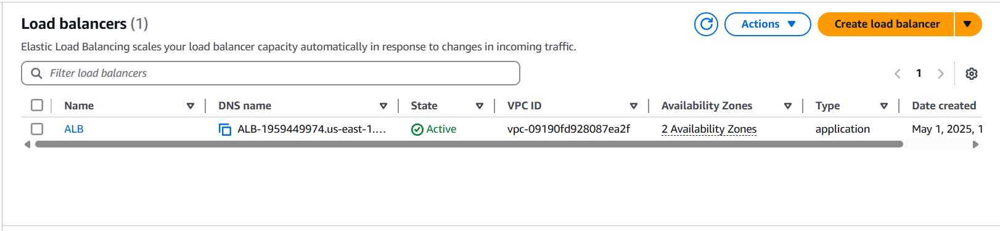

Fig: Application load balancer (ALB).

**Note:** Add the Prabhas-server to the target group of the application load balancer.

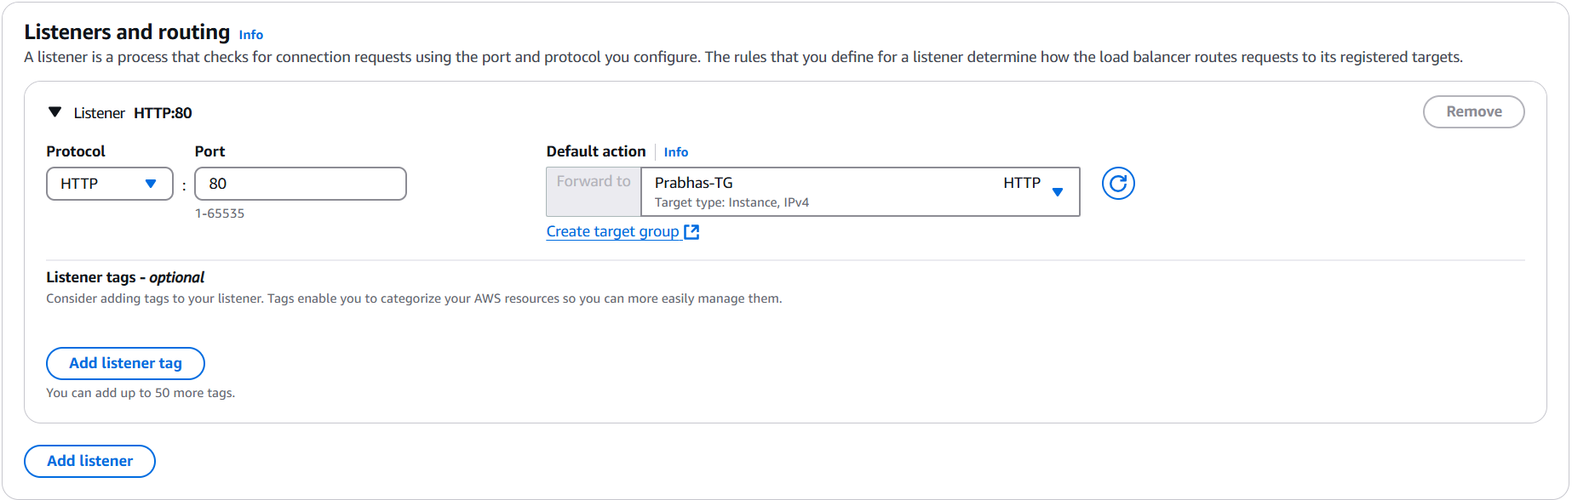

Fig: Adding target group which consist of Prabhas-server.

**Step3:** Now browse the Prabhas web page using the DNS name of Application load balancer.

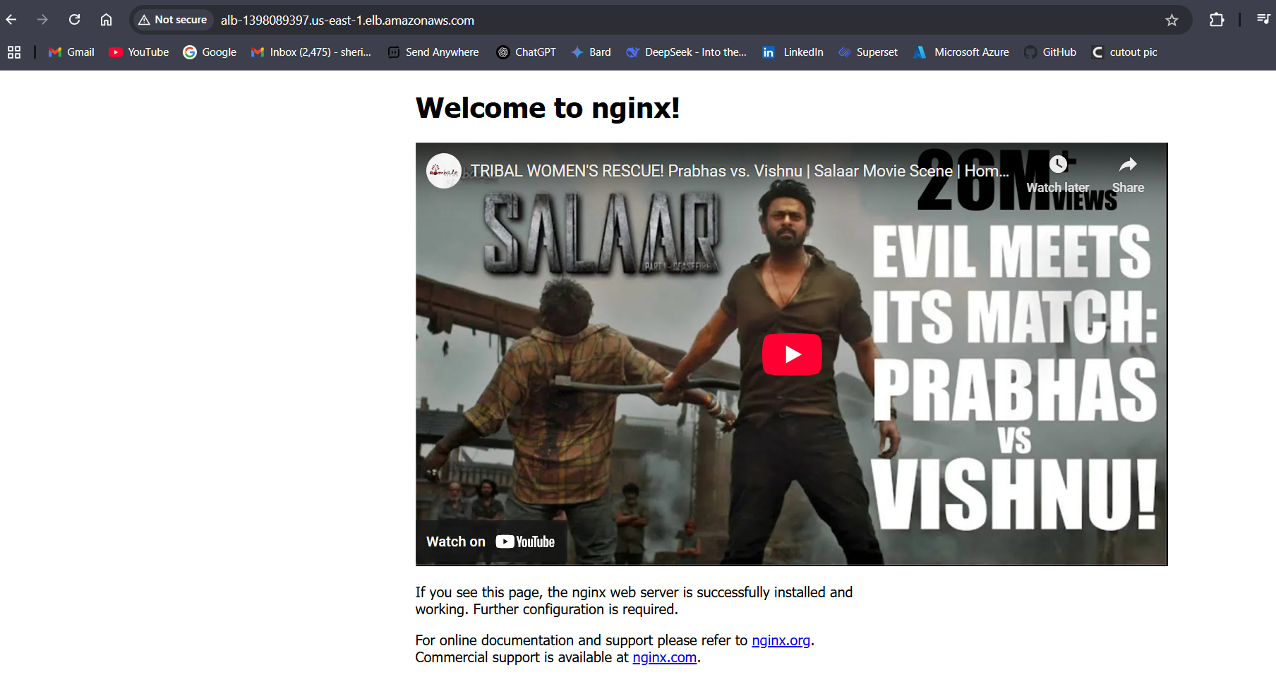

Fig: Prabhas web page.

Treat the above Prabhas web application is an older version now I want deploy the new version of surya web application using blue green deployment with zero or minimal downtime.

**Step4:** Create a new identical EC2 instance in which surya application is hosted.

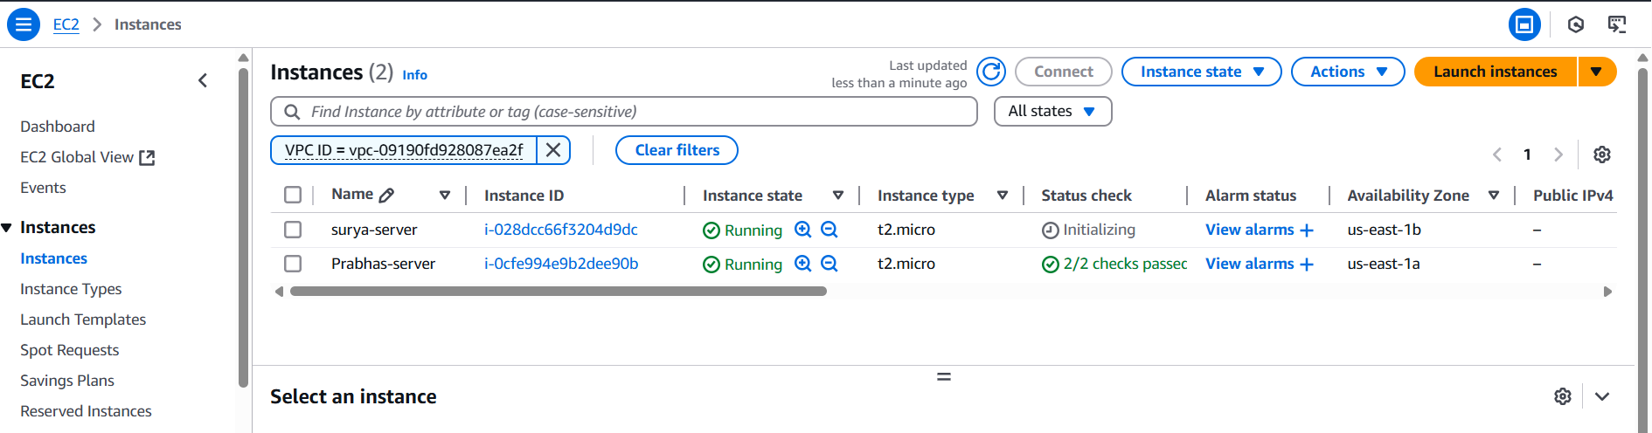

Fig: New version instance (surya-server).

Now install/deploy surya web application in this instance (surya-instance).

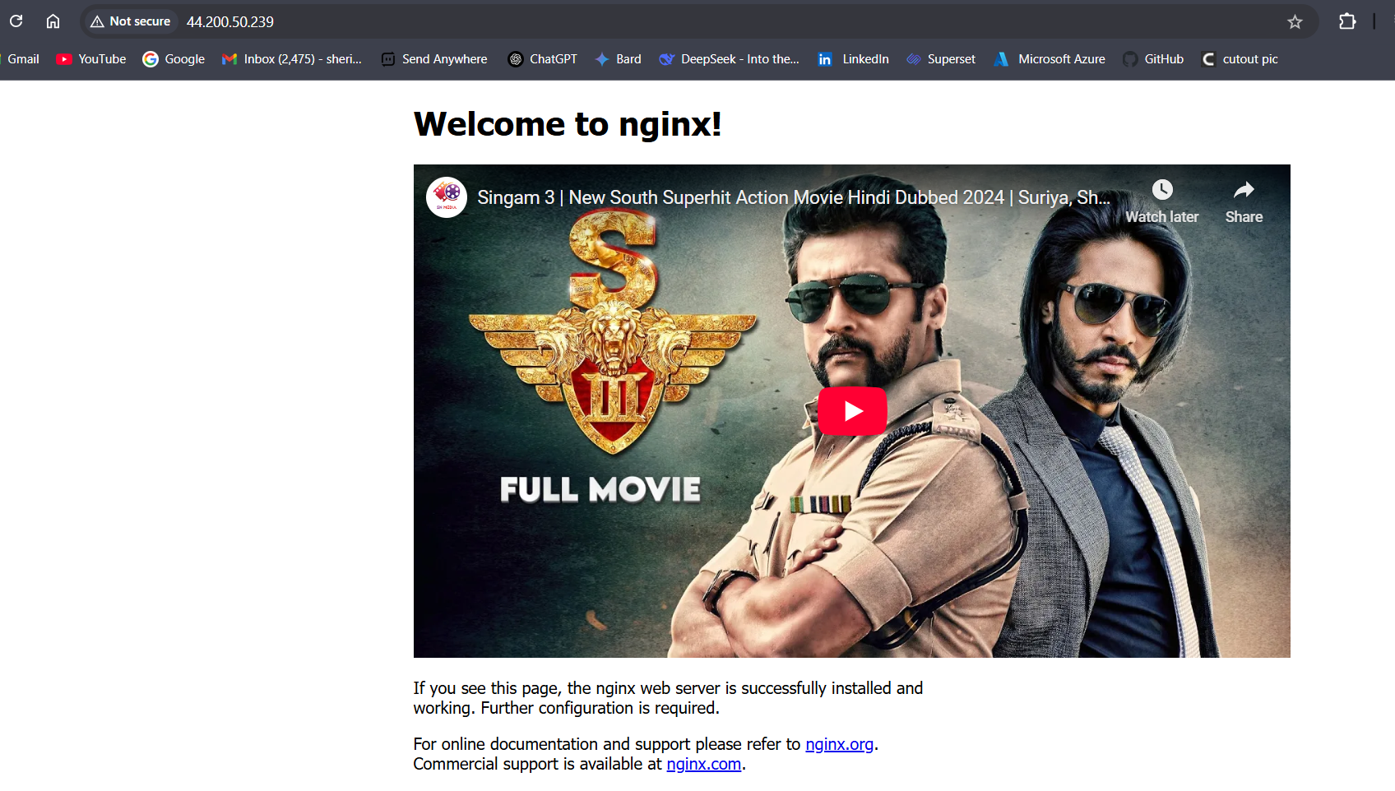

Fig: Web application which is present in surya-server instance.

**Step5:** Now add one more target group (surya-TG) with surya-server.

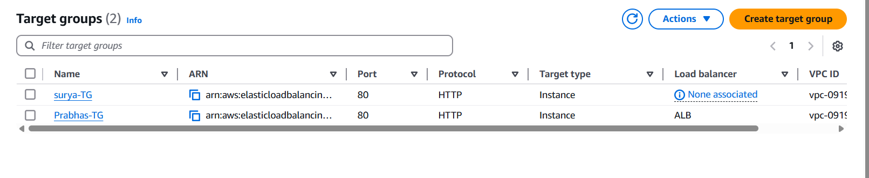

Fig: Target group (surya-TG).

Step5: Now configure this new target group (surya-TG) to the Application load balancer.

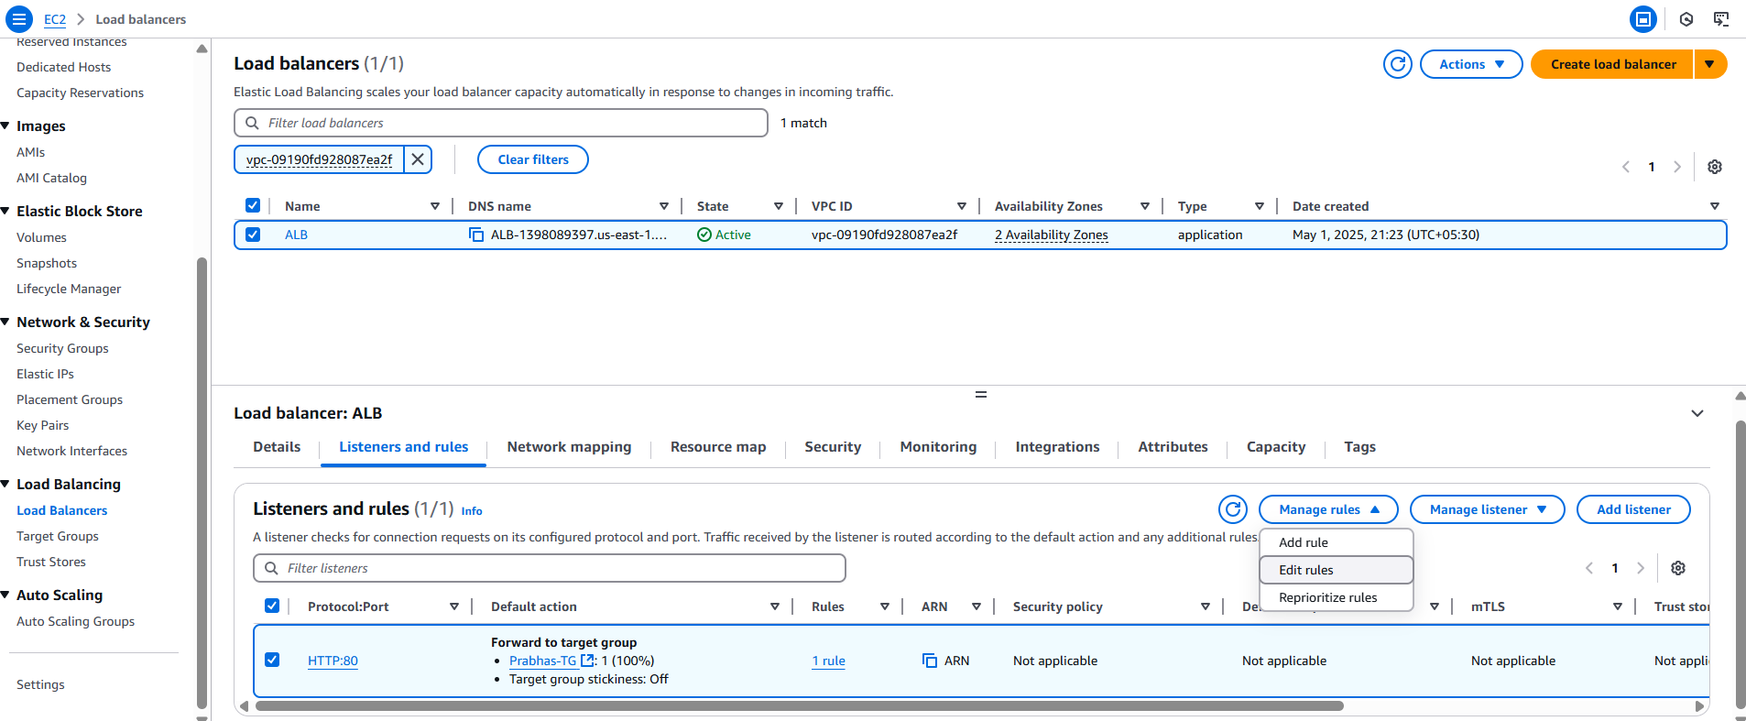

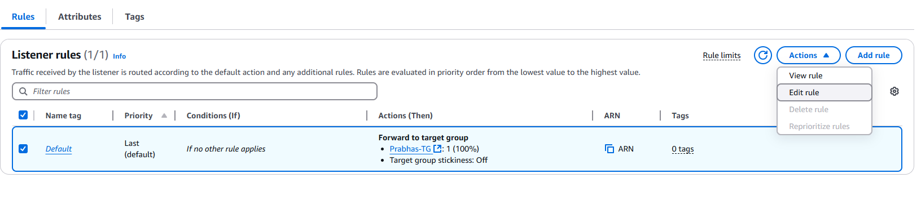

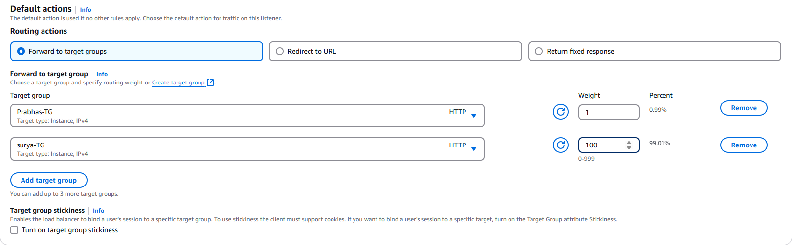

Fig: Added one more target (surya-TG) to the existing Application load balancer wit weightage of “100”.

Now the traffic switches from Prabhas-TG to the surya-TG with zero downtime as the weightage is high for surya-TG as shown below figure.

**Note:** We can use same DNS name (URL) to browse the new version.

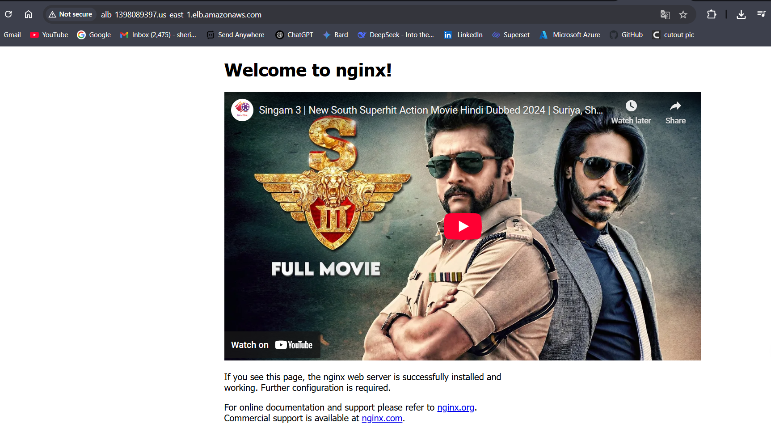

**Block Diagram of Blue-Green deployment:**

Here Load balancer acts like a switch.

USER

ALB

Surya-application

New-Version

Prabhas-application

Older-Version

Internet